7 Two Column Design

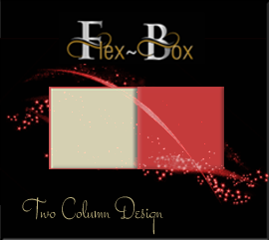

# Pseudo-Elements

Most of the code in this tutorial is fairly common, but the one thing that does stand out is the use of the pseudo-element, you can recognize the pseudo-element because you will see a double colon in the declaration of the class rule.

## HTML

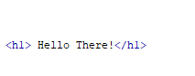

## CSS

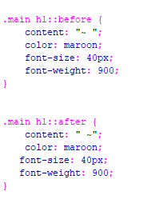

This is what this will look like with the styled tilde set to the rule::before and ::after



There are other Pseudo-elements too, and if you want to learn more about them. You can go to W3schools [Here](https://www.w3schools.com/css/css_pseudo_elements.asp).